**HTML Validation:**

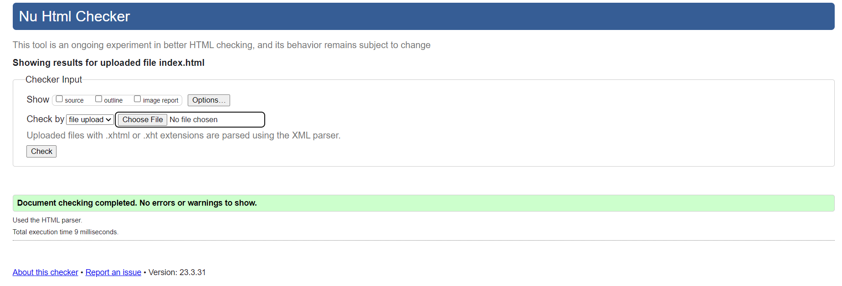

**CSS Validation:**

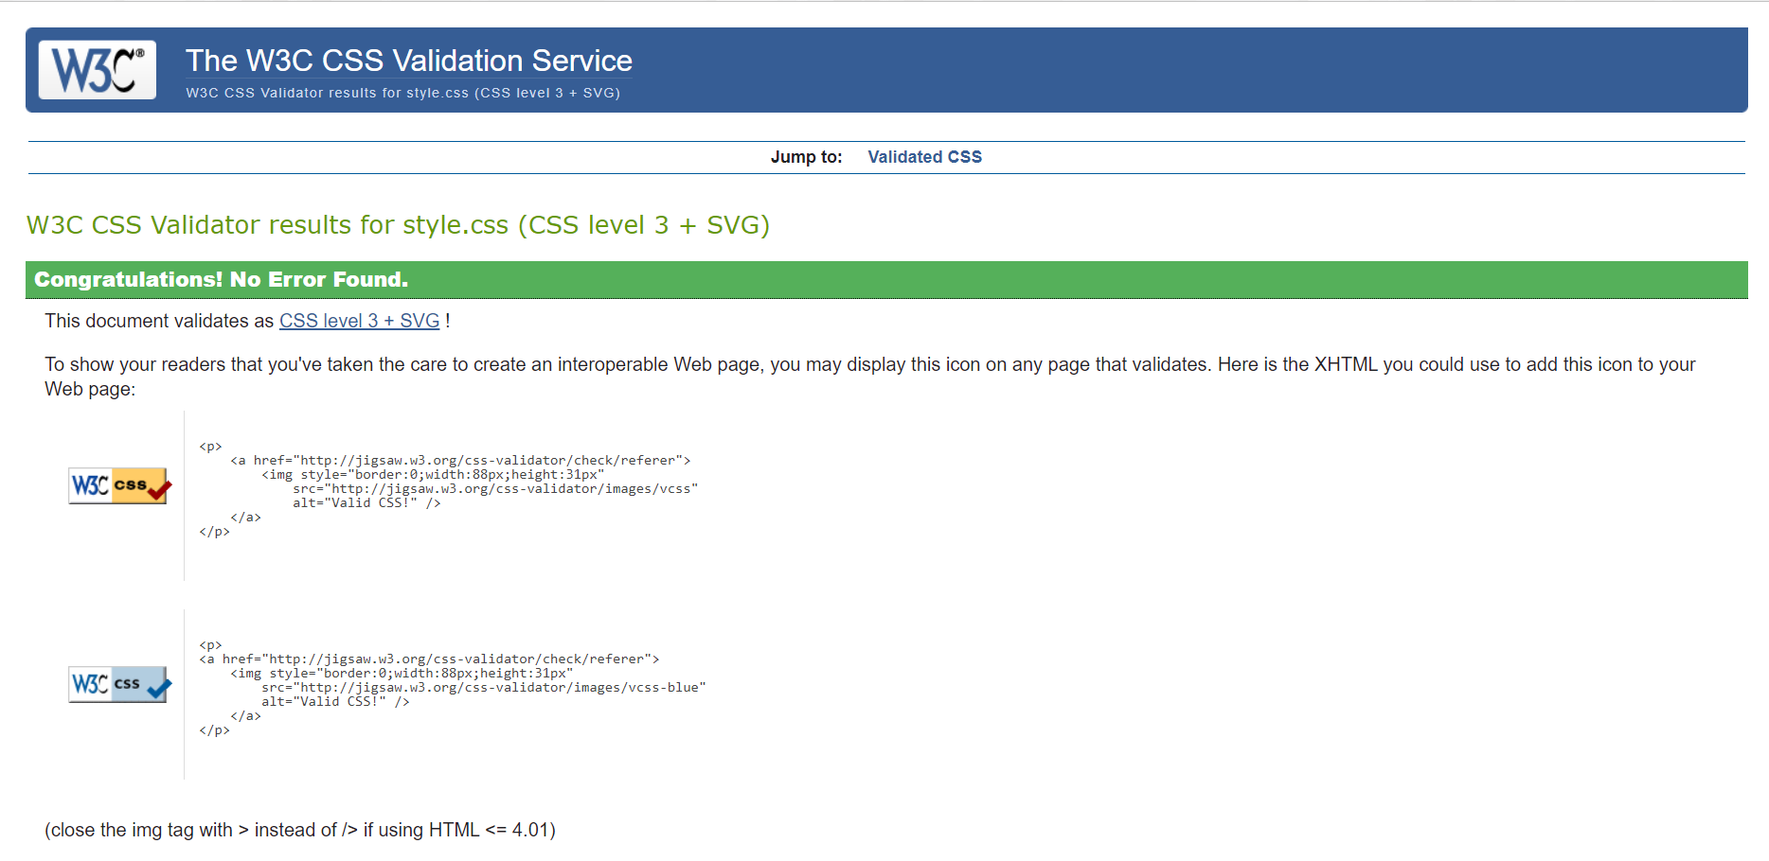

**Mobile:**

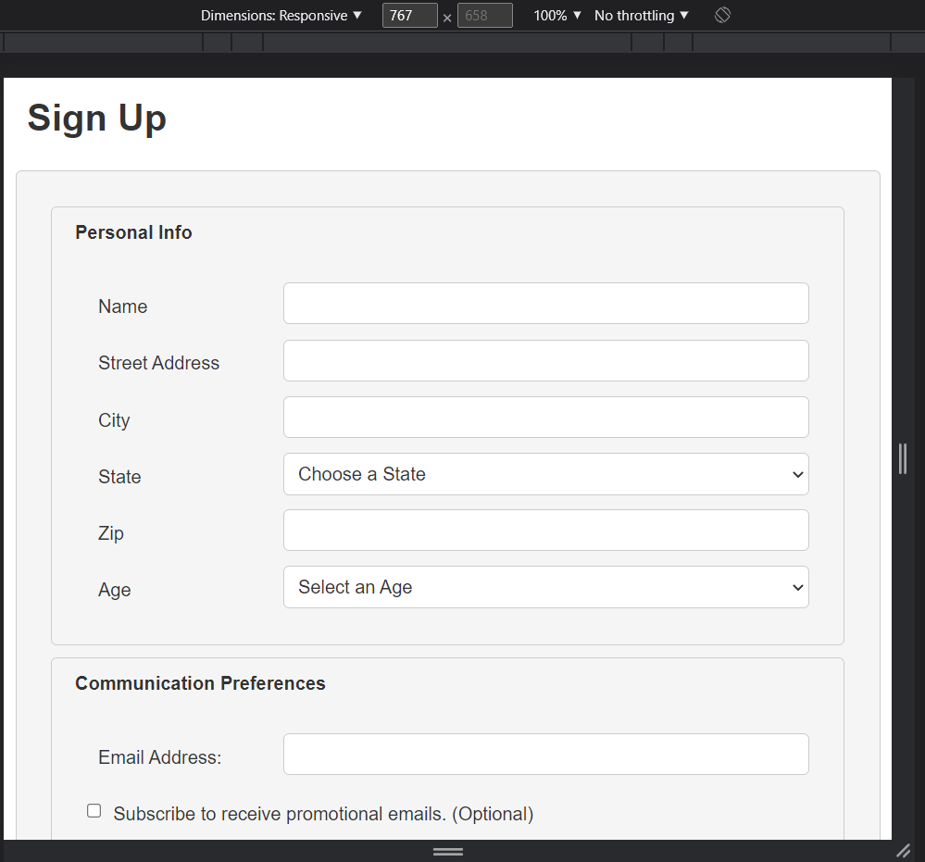

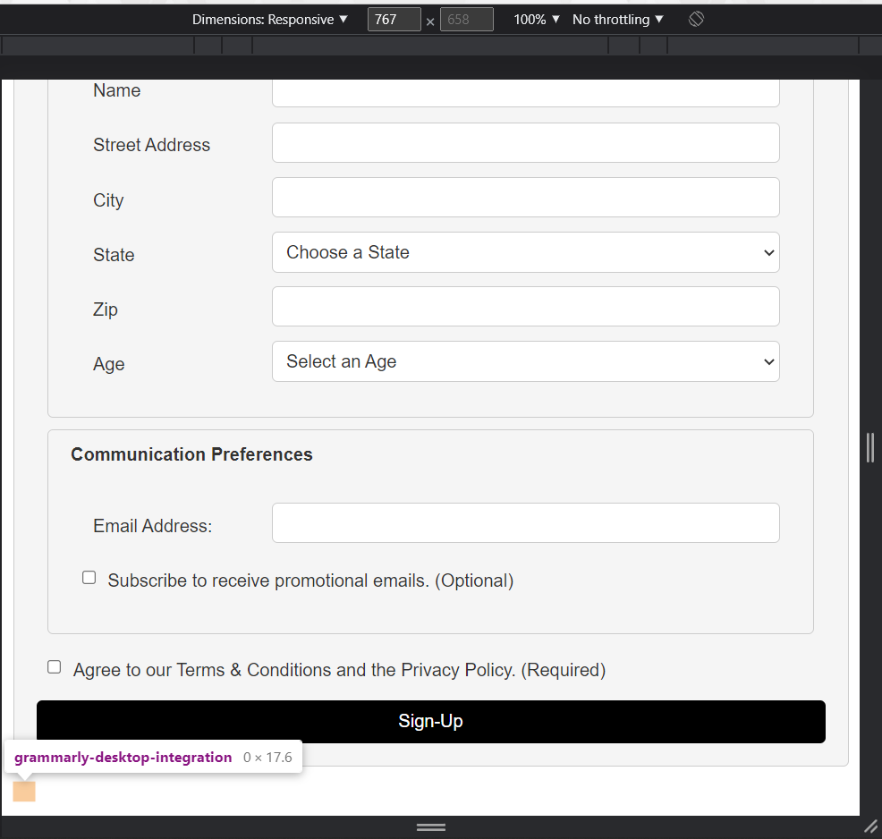

**Tablet:**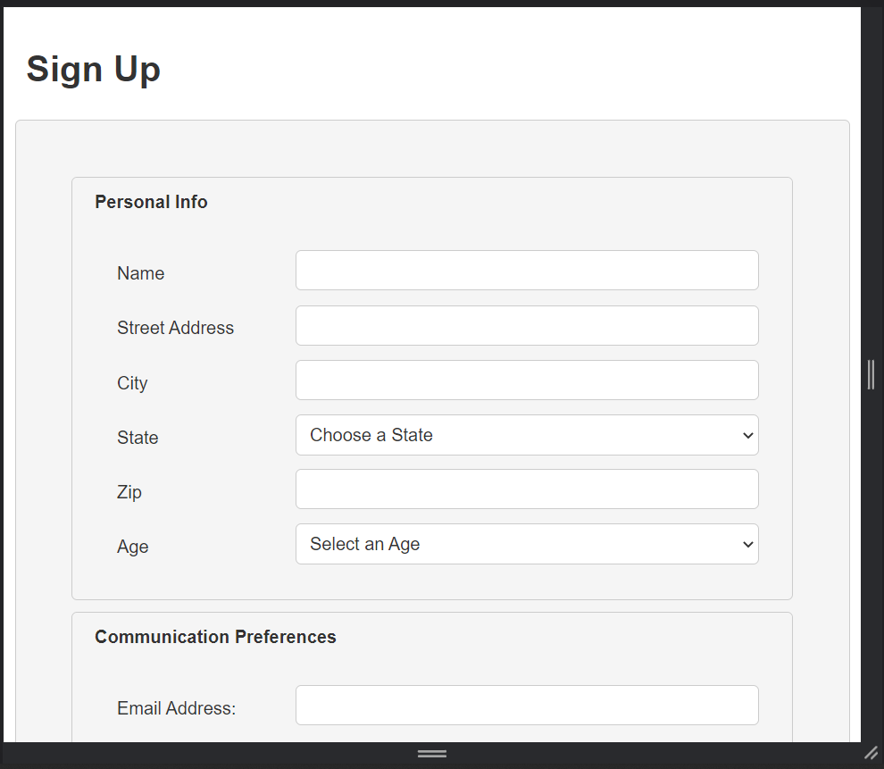

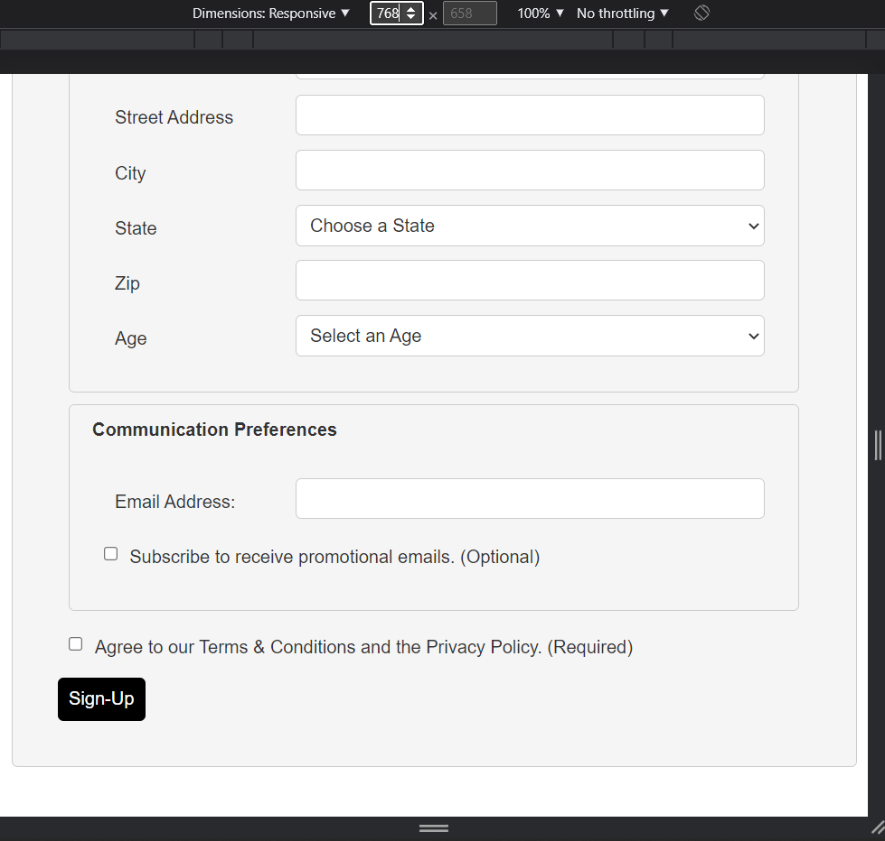

**Desktop:**

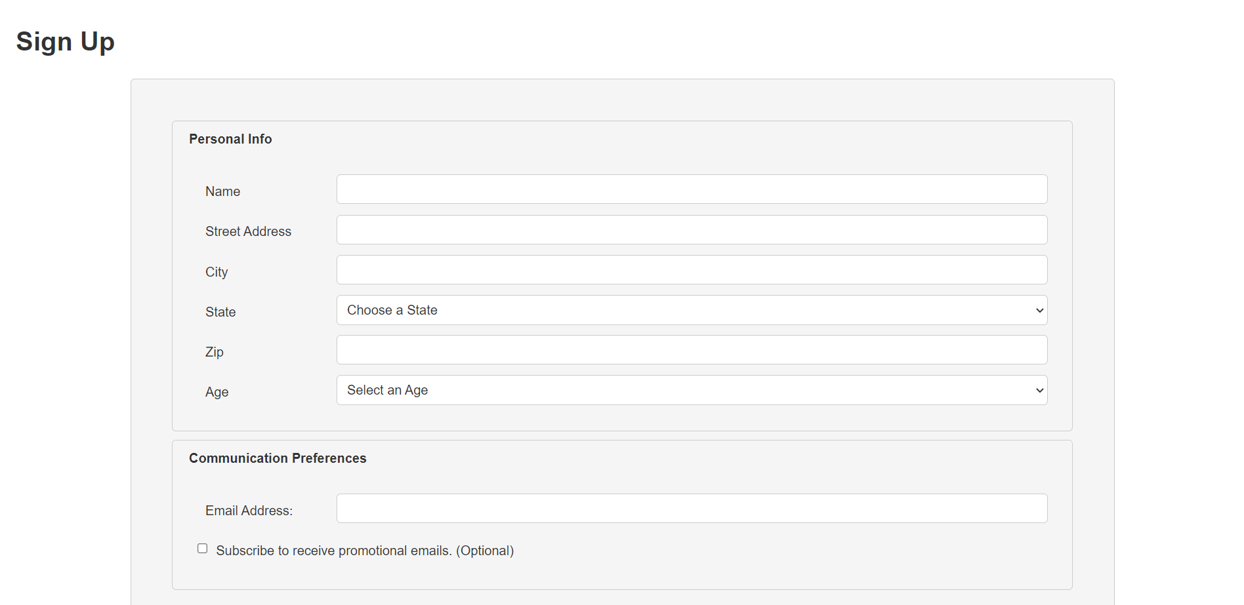

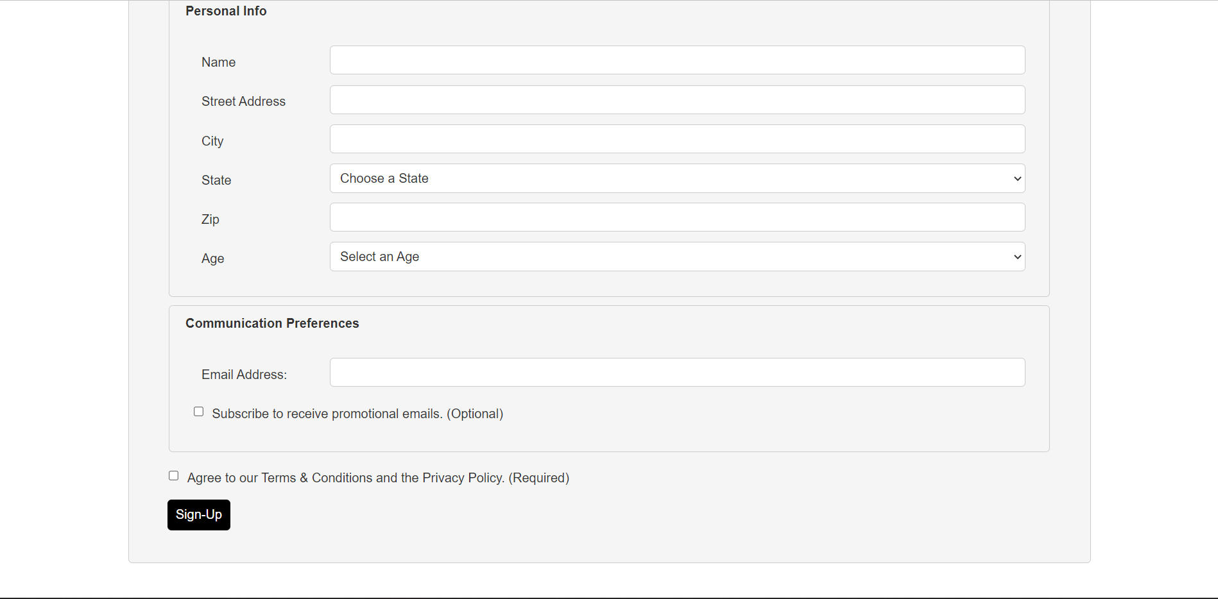

**index.html:**

<!DOCTYPE html>

<html lang="en">

<head>

    <meta charset="UTF-8">

    <meta http-equiv="X-UA-Compatible" content="IE=edge">

    <meta name="viewport" content="width=device-width, initial-scale=1.0">

    <link rel="stylesheet" href="style.css">

    <link rel="stylesheet" href="normalize.css">

    <title>Project 3: Sign-Up Form</title>

</head>

<body>

    <header>

        <h1>Sign Up</h1>

    </header>

    <form action="#" method="POST" id="signup-form">

        <div class="form-box">

          <div class="form-box-header">Personal Info</div>

          <div class="form-group">

            <label for="name">Name</label>

            <input type="text" id="name" name="name" required>

          </div>

          <div class="form-group">

            <label for="street">Street Address</label>

            <input type="text" id="street" name="street" required>

          </div>

          <div class="form-group">

            <label for="city">City</label>

            <input type="text" id="city" name="city" required>

          </div>

          <div class="form-group">

            <label for="state">State</label>

            <select id="state" name="state" required>

              <option value="" disabled selected>Choose a State</option>

              <option value="NY">New York</option>

            </select>

          </div>

          <div class="form-group">

            <label for="zip">Zip</label>

            <input type="text" id="zip" name="zip" required>

          </div>

          <div class="form-group">

            <label for="age">Age</label>

            <select id="age" name="age" required>

              <option value="">Select an Age</option>

              <option value="19">19</option>

            </select>

          </div>

        </div>

        <div class="form-box">

          <div class="form-box-header">Communication Preferences</div>

          <div class="form-group">

            <label for="email">Email Address:</label>

            <input type="text" id="email" name="email" required>

          </div>

          <div class="form-group">

            <input type="checkbox" id="subscribe" name="subscribe">

            <label for="subscribe">Subscribe to receive promotional emails. (Optional)</label>

          </div>

        </div>

        <div class="form-group">

            <input type="checkbox" id="terms" name="terms" required>

            <label for="terms">Agree to our Terms & Conditions and the Privacy Policy. (Required)</label>

          </div>

        <button type="submit">Sign-Up</button>

      </form>

</body>

</html>

**style.css:**

* {

    box-sizing: border-box;

    margin: 10px;

    padding: 0;

    font-family: Arial, sans-serif;

    font-size: 16px;

    line-height: 1.5;

    color: #333;

}

form {

    max-width: 800px;

    margin: 0 auto;

    padding: 20px;

    border: 1px solid #ccc;

    border-radius: 5px;

    background-color: #f5f5f5;

  }

  form fieldset {

    border: none;

    padding: 0;

    margin-bottom: 20px;

  }

  form label {

    display: block;

    margin-bottom: 5px;

  }

  form input[type="text"],

  form select {

    display: block;

    width: 100%;

    padding: 8px;

    border: 1px solid #ccc;

    border-radius: 5px;

    background-color: #fff;

  }

  form button[type="submit"] {

    display: block;

    width: 100%;

    padding: 10px;

    border: none;

    border-radius: 5px;

    background-color: black;

    color: #fff;

    cursor: pointer;

    margin-right: 1032px;

    margin-left: 0;

    white-space: nowrap;

}

.form-box {

    border: 1px solid #ccc;

    border-radius: 5px;

    padding: 20px;

    background-color: #f5f5f5;

  }

  .form-box-header {

    background-color: #f5f5f5;

    margin: -20px -20px 20px;

    padding: 10px 20px;

    border-top-left-radius: 5px;

    border-top-right-radius: 5px;

    font-weight: bold;

  }

.form-group {

    display: flex;

    flex-direction: row;

    align-items: center;

    margin-bottom: 10px;

    white-space: nowrap;

}

.form-group label {

    margin-right: 10px;

    flex-shrink: 0;

    width: 150px;

    white-space: nowrap;

}

  .form-group input[type="text"],

  .form-group select {

    flex-grow: 1;

    width: 100%;

  }

  form::after {

    content: "";

    display: table;

    clear: both;

  }

  @media screen and (min-width: 768px) {

    form {

      padding: 40px;

    }

    form section {

      display: flex;

      flex-wrap: wrap;

      justify-content: space-between;

    }

    form section label {

      width: 48%;

      margin-bottom: 10px;

    }

    form section input,

    form section select {

      width: 48%;

    }

    form section:nth-child(even) label,

    form section:nth-child(even) input,

    form section:nth-child(even) select {

      margin-left: 4%;

    }

    form label.checkbox {

      display: block;

    }

    form button[type="submit"] {

      width: auto;

      margin-left: auto;

    }

  }

  @media screen and (min-width: 1024px) {

    form {

      max-width: 1200px;

    }

    form section label {

      width: 30%;

    }

    form section input,

    form section select {

      width: 68%;

    }

    form section:nth-child(even) label,

    form section:nth-child(even) input,

    form section:nth-child(even) select {

      margin-left: 2%;

    }

  }